Future Connect Training

Personal development plan:

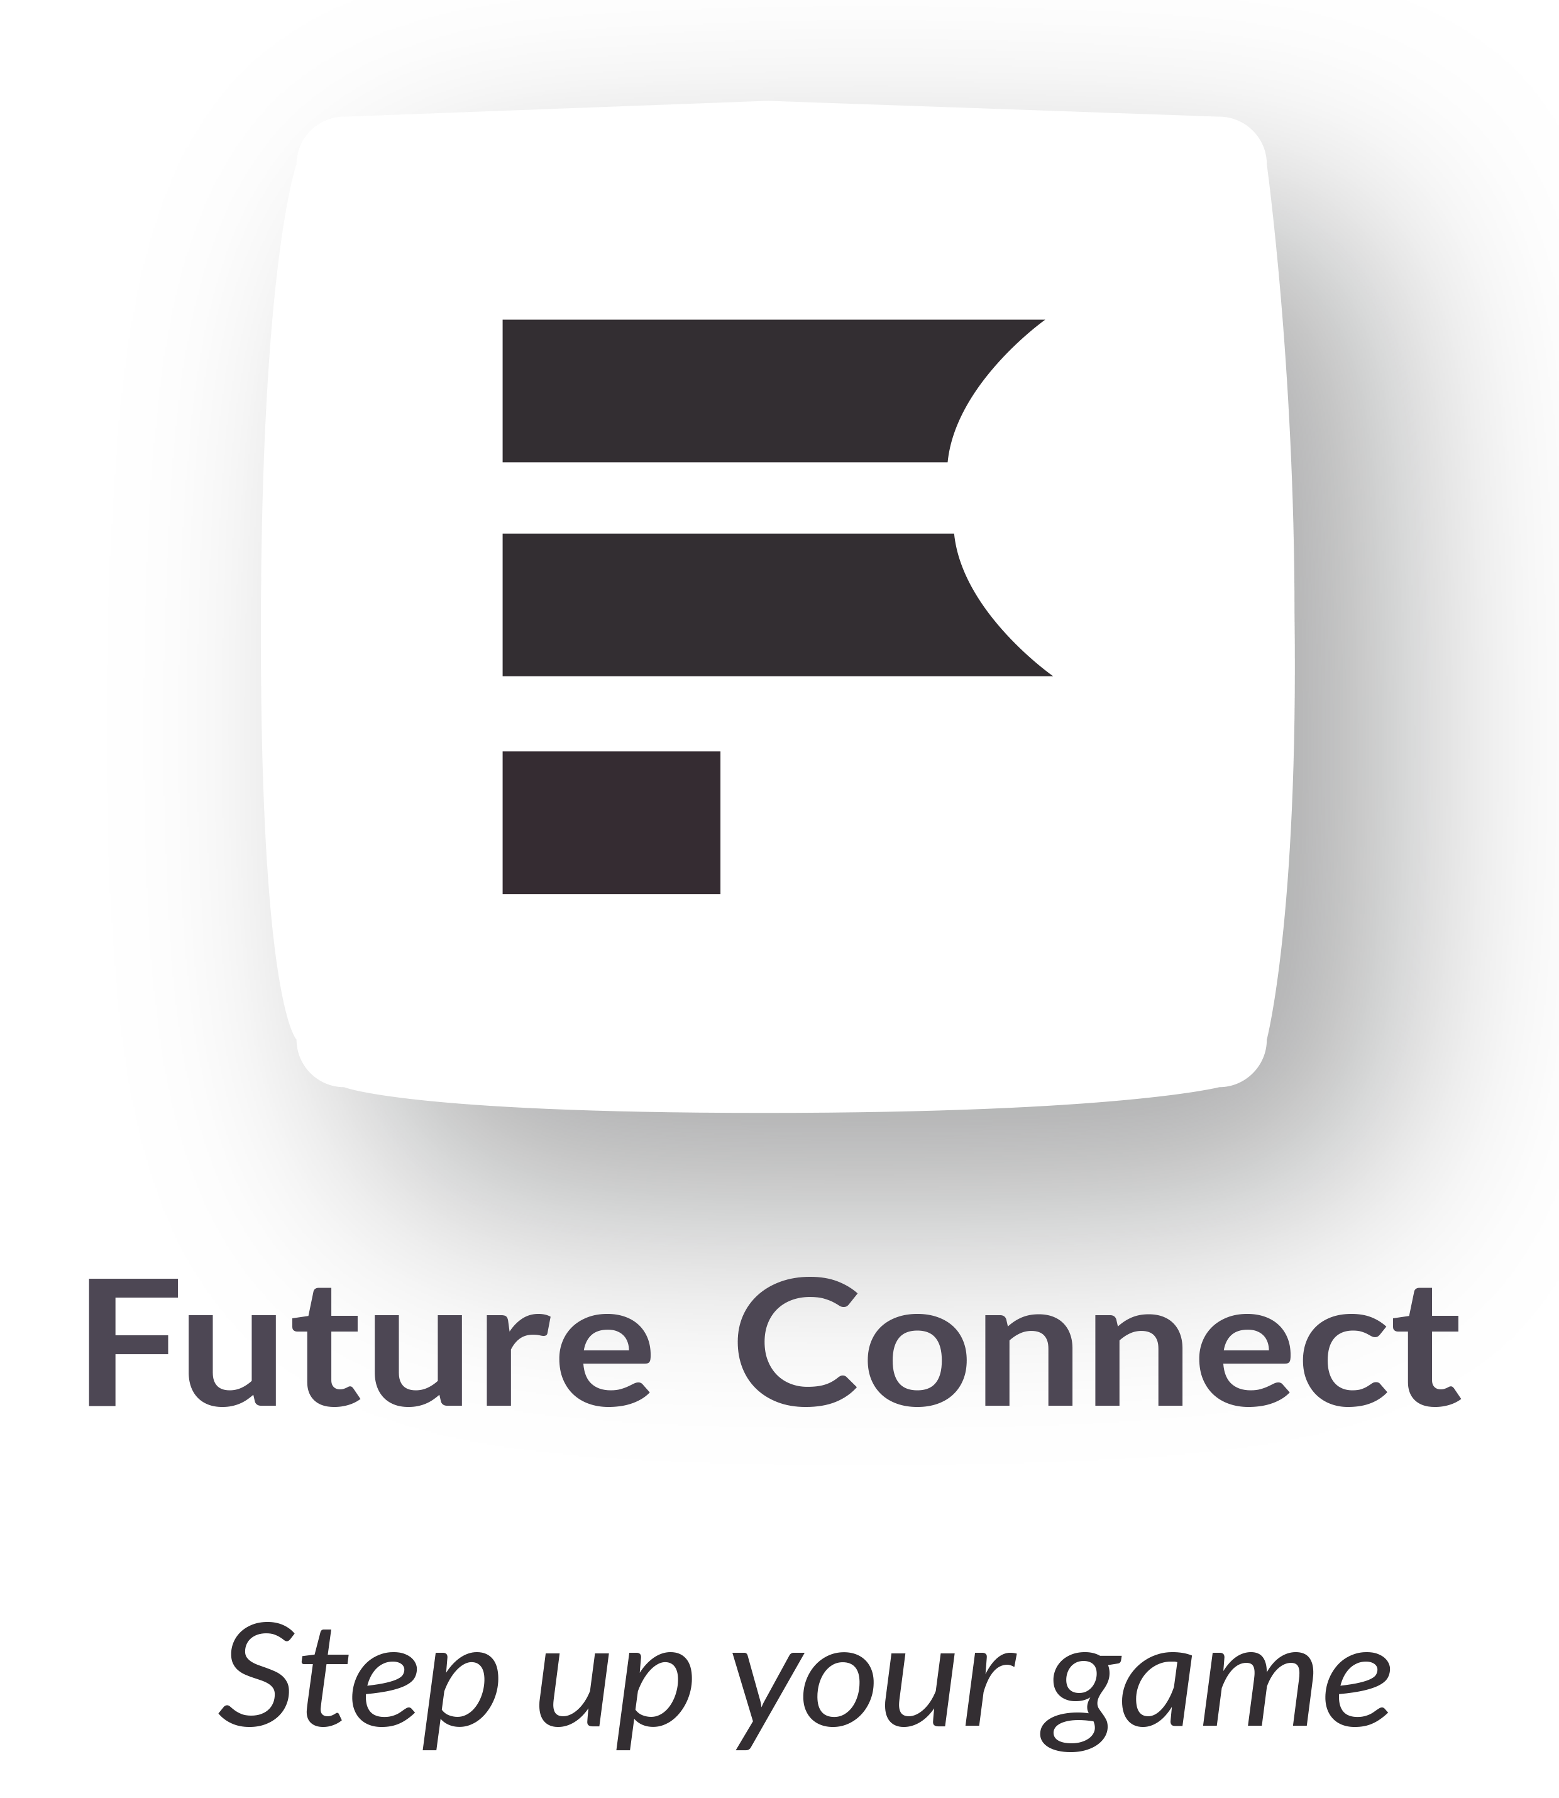

Employee Name: _________________

The personal development plan (PDP)
The PDP is designed for you to carefully consider your role as a professional, and what CPD will give you maximum benefit for maintaining and developing your practice in your current and future areas of work. We encourage you to regularly review your plan as it relates to your role and daily practice.
For the GDC, your PDP must include:
- The CPD you plan to undertake during your employment, which must include CPD that is relevant to your current or intended field(s) of work;
- The anticipated development outcomes that will link to each activity;
- The timeframes within which you expect to complete your CPD over your cycle.

The development outcomes:
You must make sure each planned and completed activity has at least one outcome (A, B, C, D) linked. It is possible for some CPD activities to link to multiple outcomes. The GDC encourages you to choose CPD to cover all four development outcomes in your cycle, however this is not a compulsory requirement.

Development Outcome | Example of CPD content
- Effective communication with Clients, the Future Connect team, including when obtaining consent, dealing with complaints, and raising concerns about any operations | - Communication skills  - Consent  - Complaints handling  - Raising concerns  - Safeguarding
- Effective management of self, and effective management of others or effective work with others in your team, in the interests of trainees at all times; providing constructive leadership where appropriate; | - Effective practice management  - Business management  - Team working
- Maintenance and development of knowledge and skill within your field of practice; | - CPD on quality assurance  - CPD specific for your daily role(s)  - Up skilling opportunities
- Maintenance of skills, behaviours and attitudes which maintain Trainee’s confidence in you and the professional support and put trainees’ interests first. | - Ethical and legal issues and developments  - Professional behaviours  - Equality and diversity training

My personal development plan
What do I need to learn or maintain for this cycle? | How does this relate to my field of practice? | Which development outcome does it link to? | What benefit will this have to my work? | How will I meet this learning or maintenance need? | When will I complete the activity?
What skills or knowledge have you identified that need developing or maintaining? Are there any gaps that need addressing? | Why have you identified this, how does it relate to your daily job, patients or tasks? | A, B, C or D  (see development outcomes table above) | How will CPD activity in this area help you to maintain or improve your daily work and/or care for patients? | What activities could you do to help meet your learning and maintenance needs? | What are your target dates for review and completion?
Insert more rows by right clicking in a row, click “insert” and “insert rows below”

